

Project Title
Heritage Treasures: An In-Depth Analysis of UNESCO World Heritage Sites in Tableau

Team ID: LTVIP2026TMIDS24102
Team Size: 4
Team Leader: Attili Nithish
Team Member: Kaila Thanmai
Team Member: Jangala Hemasri Nagalakshmi Kumari
Team Member: Guntupalli Venkata Sai Jyoshnavi

1.INTRODUCTION

1.1 Project Overview

UNESCO World Heritage Sites are places recognized for their cultural or natural importance. These sites tell the story of human history and natural wonders. Our project focuses on exploring data related to these sites using Tableau, a powerful data visualization tool. The goal is to help people understand patterns, insights, and trends in heritage preservation across the world.

1.2 Purpose
The purpose of this project is to analyze and visualize heritage site data in an interactive and meaningful way. By using Tableau, we aim to bring awareness about world heritage, show which countries have the most sites, highlight endangered sites, and help in understanding how cultural and natural heritage is spread across the globe.

2. IDEATION PHASE
  - Problem Statement
To build a data visualization dashboard that helps analyze UNESCO World Heritage Sites by country, continent, type, status, and year of inscription using Tableau.

  - Empathy Map Canvas
We focused on what heritage enthusiasts, educators, and travelers:
    - Think & Feel: Curious about history, want to explore diverse cultures
    - See: Data in boring tables, hard to understand insights
    - Hear: News about endangered sites or new additions
    - Say & Do: Look for maps, stats, and visual stories online
    - Pain: Difficult to access meaningful information easily
    - Gain: A clear, engaging, visual experience that educates and inspires

2.3 Brainstorming
We listed ideas like:
    - Creating maps of heritage site locations
    - Showing trends over time • Highlighting endangered sites
    - Comparing cultural vs natural sites
    - Using filters to allow users to explore their interests

3. REQUIREMENT ANALYSIS
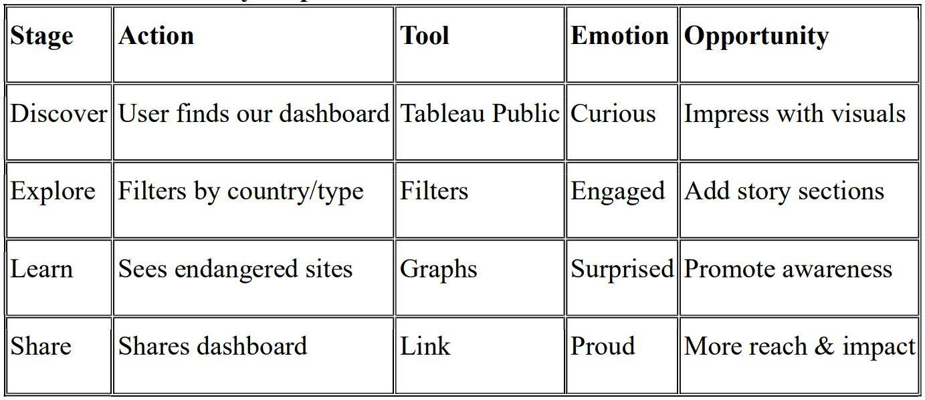
3.1Customer Journey Map

3.2 Solution Requirement
    - Dataset of UNESCO heritage sites
    - Tableau for dashboard creation
    - Charts: maps, bar charts, line graphs, pie charts
    - Filters: country, type, year, status

Data Flow Diagram
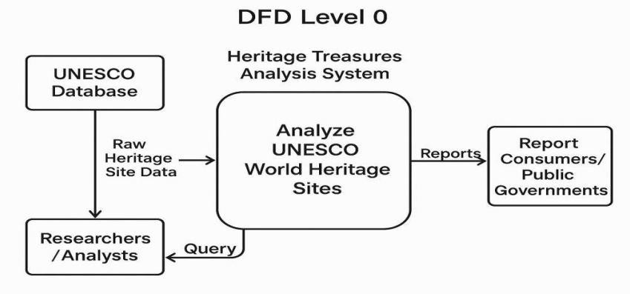

3.4 Technology Stack

    - Frontend: Tableau Public,python
    - Backend: flask(data-based project)
    - Preprocessing Tool: Excel / Google Sheets

    - DataSource:https://www.kaggle.com/datasets/ujwalkandi/unesco-world-heritage-sit es/data?select=whc-sites2019.csv

4.PROJECT DESIGN

Problem-Solution Fit
The problem was that raw heritage site data was hard to interpret. The solution was to make it interactive and visual, helping users understand it easily.

4.2 Proposed Solution
An interactive Tableau dashboard that shows insights such as:
    - Number of heritage sites per country
    - Growth over time
    - Endangered sites
    - Cultural vs Natural site comparisons

4.3 Solution Architecture
    - Data collected from UNESCO
    - Preprocessing to clean and prepare
    - Imported into Tableau
    - Dashboards created using maps, filters, and charts
    - Published on Tableau Public for public access.
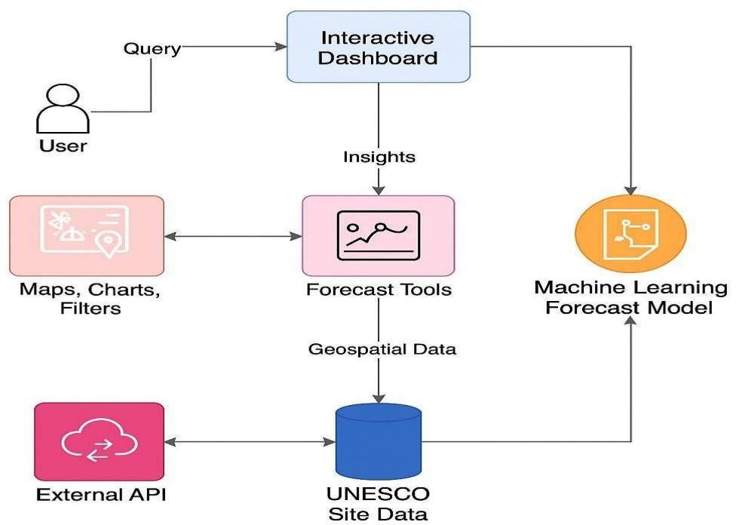

5. PROJECT PLANNING & SCHEDULING
  - Project Planning
Week Task
- Data Collection and Understanding
- Data Cleaning and Preprocessing

- Creating Dashboards in Tableau
- Designing Story Slides
5.Final Testing and Review
6. Documentation and Report Writing

6. FUNCTIONAL AND PERFORMANCE TESTING

6.1 Performance Testing
We tested the dashboard on different devices and browsers. It loaded quickly and worked well. Filters and visuals responded smoothly, and no lag was noticed.

7. RESULTS
7.1 Output Screenshots

Dashboard-1

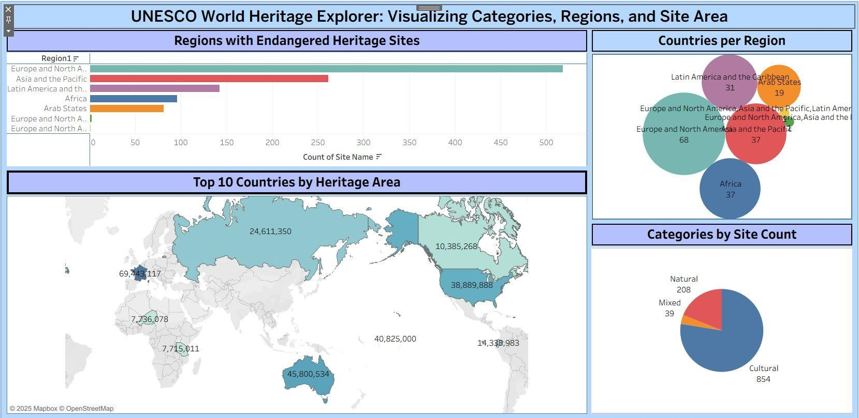
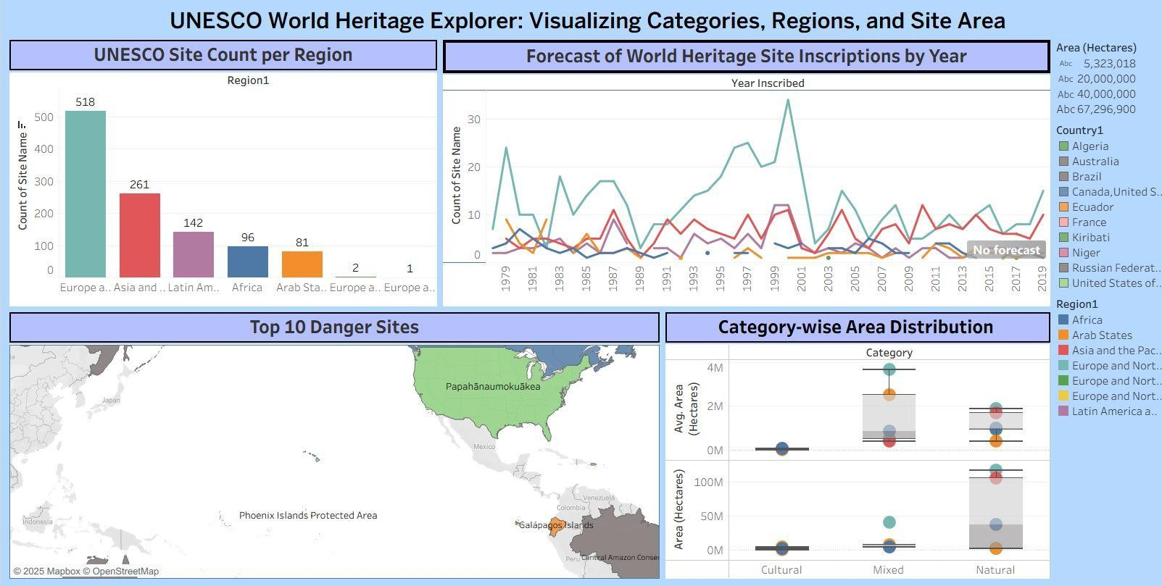
Dashboard-2:

Story:
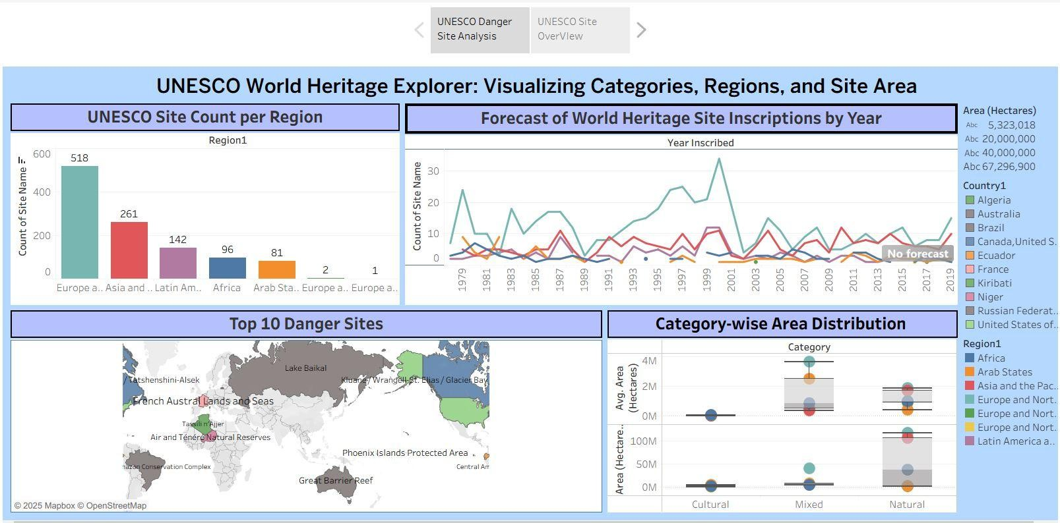
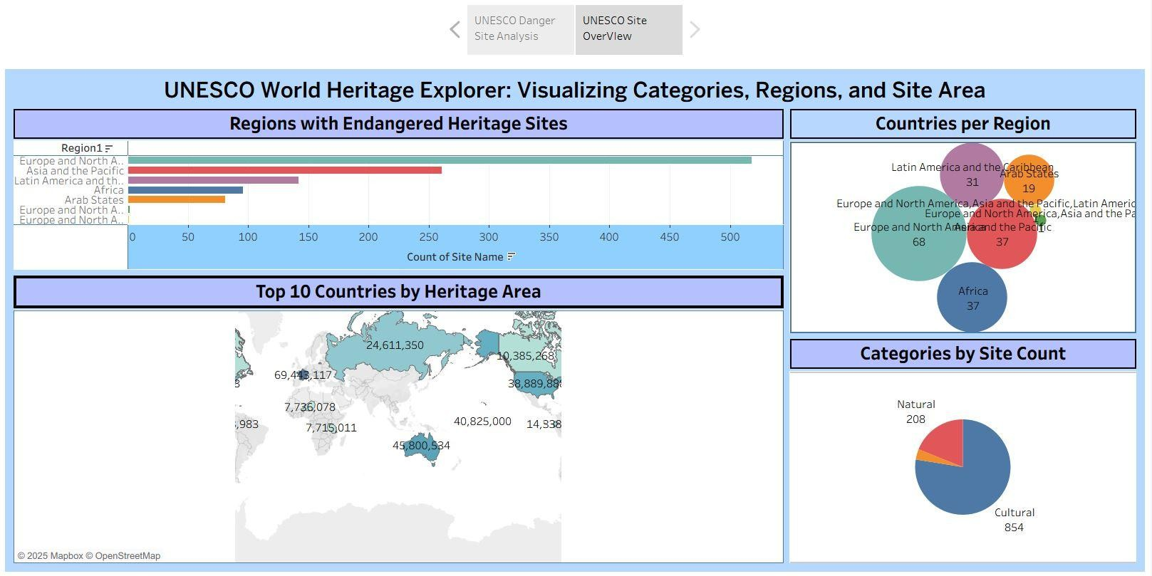

8.ADVANTAGES & DISADVANTAGES

Advantages
- Easy to understand visual data
- Interactive filters for personalized views
- Helps raise awareness about endangered sites
- Can be accessed publicly and shared

Disadvantages
- Static dataset (not live updating)
- No prediction or AI involved
- Depends on the accuracy of source data

9.CONCLUSION
The project successfully transformed a raw heritage dataset into a rich, interactive visual experience using Tableau. Users can now explore, learn, and appreciate world heritage more easily. This project shows how data science can help in promoting culture and history.

10.FUTURE SCOPE
- Add real-time data updates using APIs
- Include images or videos of sites
- Build a mobile-friendly version
- Enable AI-based recommendations or predictions

Web Integration:

Source Code:
<!DOCTYPE html>
<html lang="en">
<head>
<meta charset="UTF-8" />
<meta name="viewport" content="width=device-width, initial-scale=1" />
<title>UNESCO Sites Visualization</title>
<link href="https://cdn.jsdelivr.net/npm/bootstrap@5.3.3/dist/css/bootstrap.min.css" rel="stylesheet" />
<link href="https://cdnjs.cloudflare.com/ajax/libs/animate.css/4.1.1/animate.min.css" rel="stylesheet" />
<link href="https://unpkg.com/aos@2.3.1/dist/aos.css" rel="stylesheet" />
<style>
:root {
--bg-light: #e8f5e9;
--bg-dark: #1b1b1b;
--text-light: #ffffff;
--text-dark: #000000;
--card-bg-light: #ffffff;
--card-bg-dark: #2e2e2e;
--border-accent: #00796b;
}
body {
background: var(--bg-light);
color: var(--text-dark);
font-family: 'Segoe UI', Tahoma, Geneva, Verdana, sans-serif;
transition: background 0.4s ease, color 0.4s ease;
scroll-behavior: smooth;
}

.dark-mode {
background: var(--bg-dark);
color: var(--text-light);
}
.navbar {
background: linear-gradient(to right, #004d40, #00796b);
box-shadow: 0 2px 10px rgba(0,0,0,0.2);
}
.navbar-brand, .nav-link {
color: white !important;
}

.header {
text-align: center;
margin-bottom: 3rem;
padding: 2rem;
background: linear-gradient(to right, #004d40, #00796b);
color: white;
border-radius: 1rem;
box-shadow: 0 4px 20px rgba(0,0,0,0.2);
}
.tableau-card {
background: var(--card-bg-light);
border-radius: 1rem;
border: 3px solid var(--border-accent);
box-shadow: 0 4px 20px rgba(0,0,0,0.1);
padding: 1.5rem;
margin-bottom: 3rem;
transition: transform 0.3s ease;
}
.dark-mode .tableau-card {
background: var(--card-bg-dark);
border-color: #26a69a;
}
.tableau-card:hover {
transform: scale(1.01);
}
.tableauViz {
width: 100%;
border-radius: 1rem;
}
.title-bar {
text-align: center; font-size: 1.6rem; font-weight: bold;
margin-bottom: 1.2rem; color: #004d40;
}

footer {
background-color: #004d40; color: white;
padding: 1rem; text-align: center; margin-top: 4rem;
}

.mode-toggle {
cursor: pointer; border: none;
background: transparent; color: white;
font-size: 1.2rem;
margin-left: 1rem;
}
.scroll-indicator { position: fixed; top: 0;
left: 0; height: 4px;
background: #00796b; z-index: 9999;
transition: width 0.2s ease;
}
</style>
</head>
<body>
<div class="scroll-indicator" id="scrollIndicator"></div>

<nav class="navbar navbar-expand-lg sticky-top">
<div class="container">
<a class="navbar-brand" href="#">UNESCO Visualizer</a>
<button class="navbar-toggler" type="button" data-bs-toggle="collapse" data-bs-target="#navbarNav">
<span class="navbar-toggler-icon"></span>
</button>
<div class="collapse navbar-collapse" id="navbarNav">
<ul class="navbar-nav ms-auto">
<li class="nav-item"><a class="nav-link" href="#dashboard1">Dashboard 1</a></li>
<li class="nav-item"><a class="nav-link" href="#dashboard2">Dashboard 2</a></li>
<li class="nav-item"><a class="nav-link" href="#story">Story</a></li>
<li class="nav-item"><button class="mode-toggle" onclick="toggleMode()">🌓</button></li>
</ul>
</div>
</div>
</nav>

<div class="container py-4">
<div class="header animate_animated animate_fadeInDown">
<h1 class="display-5">UNESCO World Heritage Sites</h1>
<p class="lead">Dive into dashboards & stories exploring global cultural treasures</p>
</div>

<div class="tableau-card" id="dashboard1" data-aos="fade-up">
<div class="title-bar">Dashboard: Site Overview</div>
<div class='tableauPlaceholder' id='viz1751201541883'>
<noscript><a href='#'><img alt='Dashboard 1' src='https://public.tableau.com/static/images/UN/UNESCOSiteOverView/Dashbo ard1/1_rss.png'/></a></noscript>
<object class='tableauViz' style='display:none;'>
<param name='host_url' value='https%3A%2F%2Fpublic.tableau.com%2F'/>
<param name='embed_code_version' value='3'/>
<param name='path' value='views/UNESCOSiteOverView/Dashboard1?:embed=true'/>
<param name='toolbar' value='yes'/>
</object>
</div>
</div>

<div class="tableau-card" id="dashboard2" data-aos="fade-up">
<div class="title-bar">Dashboard: Danger Site Analysis</div>
<div class='tableauPlaceholder' id='viz1751201813353'>
<noscript><a href='#'><img alt='Dashboard 2' src='https://public.tableau.com/static/images/UN/UNESCODangerSiteAnalysis/D ashboard2/1_rss.png'/></a></noscript>
<object class='tableauViz' style='display:none;'>
<param name='host_url' value='https%3A%2F%2Fpublic.tableau.com%2F'/>
<param name='embed_code_version' value='3'/>
<param name='name' value='UNESCODangerSiteAnalysis/Dashboard2'/>
<param name='toolbar' value='yes'/>
</object>
</div>
</div>

<footer>
&copy; 2025 UNESCO Visualizer | Crafted with 🌍 using Bootstrap & Tableau
</footer>

<script src="https://cdn.jsdelivr.net/npm/bootstrap@5.3.3/dist/js/bootstrap.bundle.min.js"
></script>
<script src="https://unpkg.com/aos@2.3.1/dist/aos.js"></script>
<script>AOS.init();</script>

<script type='text/javascript'>
const loadTableau = (id) => {
const div = document.getElementById(id);
const viz = div.getElementsByTagName('object')[0];
viz.style.display = 'block';
viz.style.width = '100%';
viz.style.height = '850px';
const script = document.createElement('script');
script.src = 'https://public.tableau.com/javascripts/api/viz_v1.js';
viz.parentNode.insertBefore(script, viz);
};

loadTableau('viz1751201541883');
loadTableau('viz1751201813353');
loadTableau('viz1751201963895');

function toggleMode() {
document.body.classList.toggle('dark-mode');
}

window.onscroll = () => {
const scrollIndicator = document.getElementById("scrollIndicator");
const winScroll = document.body.scrollTop ||
document.documentElement.scrollTop;
const height = document.documentElement.scrollHeight - document.documentElement.clientHeight;
const scrolled = (winScroll / height) * 100;
scrollIndicator.style.width = scrolled + "%";
};
</script>
</body>
</html>

Github Repository Link:
https://github.com/Hemasri-077/Heritage-Treasures-An-In-Depth-Analysis-of-UNESCO-World-Heritage-Sites-in-Tableau

